6. Vacuum Cleaner Problem
Aim:
To simulate the behavior of a vacuum cleaner agent in cleaning dirty rooms.
Procedure:
- Read the initial state of the rooms.
- Detect whether the current room is dirty.
- Clean the room if necessary.
- Move to the next room.
- Repeat until all rooms are clean.
- Display the actions performed.
Output:
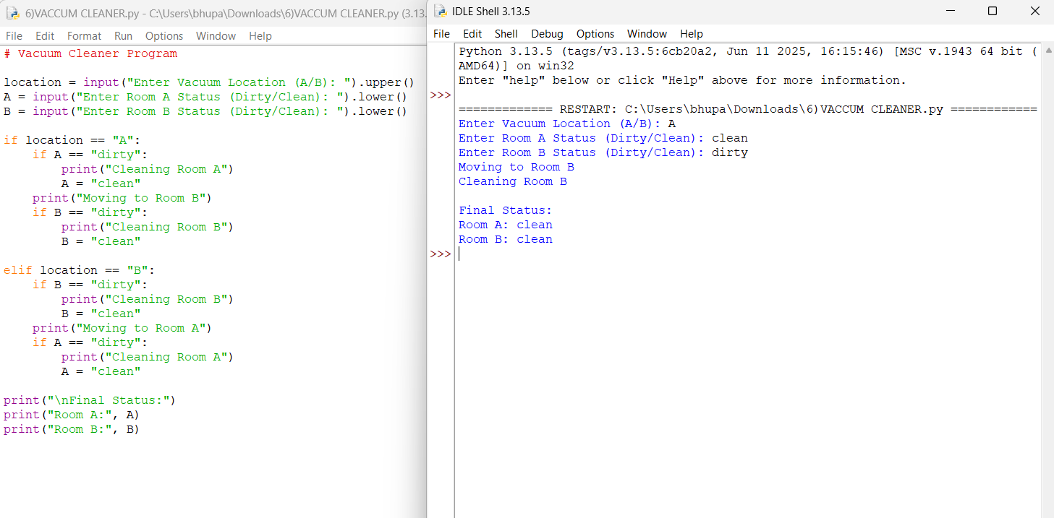 Result:
All rooms were cleaned successfully by the vacuum cleaner agent.

